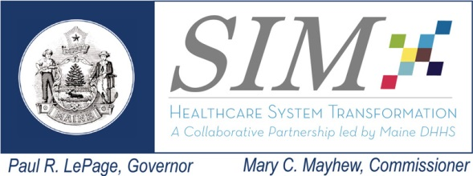  This work is made possible with funding from the Maine State Innovation Model Initiative | Workgroup: Accountable Care Implementation (ACI)  Date: September 16, 2014  Time: 3:00 to 5:00 pm  Location: MaineGeneral Medical Center, Conf. Rm. 3  Remote Access: See GoToMeeting link below
Meeting Goals: Provide a presentation on the Maine Community ACO which includes FQHCs and is administered by Universal American and engage in a group dialogue on how to accelerate payment reform in the Maine market.
----- Agenda -----
Topics Lead Time
- Welcome and meeting overview |  | Frank Johnson | 3:00 – 3:15
- Medicare Shared Savings: Maine Community ACO |  | Jude Neveux, Universal American | 3:15 – 4:00
- Group dialogue on accelerating payment reform  - Snapshot of today’s status  - Role of stakeholders to advanced payment reform  - Next steps |  | Frank Johnson | 4:00 – 4:45
- Next meeting |  | Frank Johnson | 4:45 – 5:00

ACI Committee September 16th GoToMeeting Info:
1. Please join my meeting.
https://global.gotomeeting.com/meeting/join/952689037
2. Use your microphone and speakers (VoIP) - a headset is recommended. Or, call in using your telephone.
United States: +1 (213) 493-0606
Access Code: 952-689-037
Audio PIN: Shown after joining the meeting
Meeting ID:952-689-037

